**Canada Malting Co. White Wheat Malt**

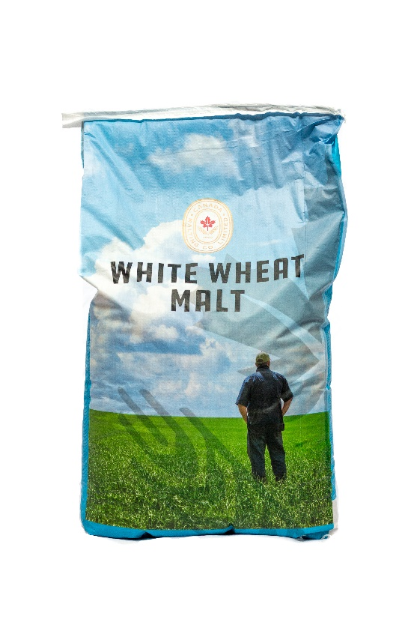

|  |
| --- |
| **Gotham Product Code:**  **9857** |
| **Manufacturer Code:**  **CM-WHET** |
| **Pack Size:**  **55 lb Bag** |